

**LAB # 1**



**DATED:**

**17th October, 2022**

**SUBMITTED TO:**

**Engr. Rehmat Ullah**

**CSE-202L Digital Logic Design Lab**

**Fall 2022**

**SUBMITTED BY:**

**Ali Asghar(21PWCSE2059)**

**Suleman Shah(21PWCSE1983)**

**Abu Bakar(21PWCSE2004)**

**Department of Computer Systems Engineering**

**University of Engineering & Technology, Peshawar**

Digital Logic Gates

CSE-202L: Digital Logic Design Laboratory

INTRODUCTION:

Digital circuits makeup the cornerstone of modern computational hardware. By representing binary digits (i.e. {0,1}) with voltage levels, digital circuits are able to process binary numbers electronically. *Logic gates* are the fundamental components within digital circuits so understanding their behavior is important. Therefore, the purpose of this experiment is to introduce you to gate behavior and logic interpretation as well as the basics of circuit wiring and troubleshooting. To do so, we will explore the function of several of the basic *logic gates* discussed in lecture.

DIGITAL LOGIC GATES:

Digital systems are said to be constructed by using logic gates. These gates are the AND, OR, NOT, NAND, NOR, EXOR and EXNOR gates. The basic operations are described below with the aid of truth tables.

AND gate:

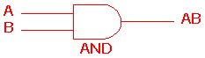 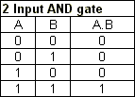

The AND gate is an electronic circuit that gives a high output (1) only if all its inputs are high.  A dot (.) is used to show the AND operation i.e., A.B.  Bear in mind that this dot is sometimes omitted i.e., AB

OR gate:

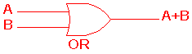 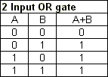

The OR gate is an electronic circuit that gives a high output (1) if one or more of its inputs are high.  A plus (+) is used to show the OR operation.

NOT gate:

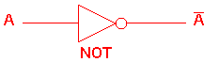 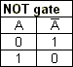

The NOT gate is an electronic circuit that produces an inverted version of the input at its output.  It is also known as an inverter.  If the input variable is A, the inverted output is known as NOT A.  This is also shown as A', or A with a bar over the top, as shown at the outputs. The diagrams below show two ways that the NAND logic gate can be configured to produce a NOT gate. It can also be done using NOR logic gates in the same way.

**http://www.ee.surrey.ac.uk/Projects/CAL/digital-logic/gatesfunc/graphics/NOT.gif**

NAND gate:

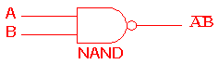 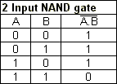

This is a NOT-AND gate which is equal to an AND gate followed by a NOT gate.  The outputs of all NAND gates are high if any of the inputs are low. The symbol is an AND gate with a small circle on the output. The small circle represents inversion.

NOR gate:

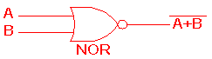 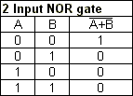

This is a NOT-OR gate which is equal to an OR gate followed by a NOT gate.  The outputs of all NOR gates are low if any of the inputs are high.

The symbol is an OR gate with a small circle on the output. The small circle represents inversion.

EXOR gate:

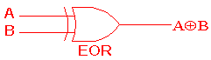 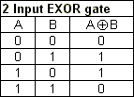

The 'Exclusive-OR' gate is a circuit which will give a high output if either, but not both, of its two inputs are high.  An encircled plus sign (**http://www.ee.surrey.ac.uk/Projects/CAL/digital-logic/gatesfunc/graphics/enplus.gif**) is used to show the EOR operation.

EXNOR gate

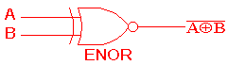 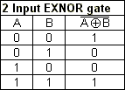

The 'Exclusive-NOR' gate circuit does the opposite to the EOR gate. It will give a low output if either, but not both, of its two inputs are high. The symbol is an EXOR gate with a small circle on the output. The small circle represents inversion.

74XX SERIES OF LOGIC GATES:

74XX is the most popular logic family in [integrated circuits](https://www.elprocus.com/different-types-of-integrated-circuits/). Texas Instruments has introduced the first logic chip namely SN5400 series **TTL (transistor-transistor logic)** in the year **1964**. Later on, SN7400 series logic chip was introduced in the year **1966**. These chips were gained above 50% of the logic chip market quickly. Finally, these ICs are becoming consistent [electronic components](https://www.elprocus.com/major-electronic-components/). In the past decade, there are different pin-compatible generations with descendant families were developed to give support for lower-power supply voltages, low-power [**CMOS** technology](https://www.elprocus.com/cmos-working-principle-and-applications/), & surface-mount packages.

SPECIFICATIONS OF 74XX SERIES IC’s:

Some of the specifications and features of 7400 IC include the following.

* The voltage supply is 5 V
* Propagation delay for each gate will be 10 ns
* Maximum toggle speed is 25 MHz
* Power utilization for each gate is 10 mW
* Independent 2-i/p NAND Gates- 4
* The output can be interfaced with TTL, NMOS, CMOS.
* The range of operating voltage will be large
* Operating conditions are extensive
* Not suitable for new designs which use 74LS00
* Using 7400 family-based integrated circuits, an engineer can design flip-flops (FFs), counters, buffers, and [logic gates](https://www.elprocus.com/basic-logic-gates-with-truth-tables/) in different packages, and these can be connected as preferred to solve an exact problem

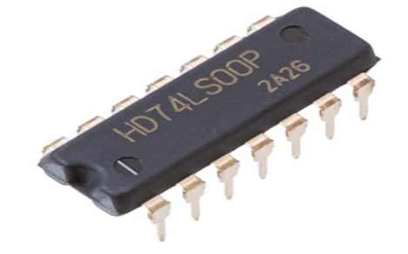.

7400 TTL IC

PIN OUT DIAGRAMS OF 74XX SERIES LOGIC IC’s

LAB PROCEDURE

We will look at the behavior of logic gates. Each of these gates is embedded in an integrated circuit package. Consult the datasheets of each component for the pin-outs, electrical and timing characteristics of these circuits. All datasheets are available on www.alldatasheet.com.

3.1 EXPERIMENT 1

We will start by setting up the DC power supply and multi-meter for our use. Be sure both are turned off. Then check to see that the multi-meter is set to measure DC, and be sure the red lead is connected to the red multi-meter input that is marked for voltage. Finally, set the scale to the range you need to measure (usually between 0V to 5V for digital circuits). Now, set the DC power supply voltage output to zero (turn the coarse adjustment counterclockwise until it stops). Connect the red lead of the power supply to the red lead of the multi-meter. Likewise, connect the black lead of the power supply to the black lead of the multi-meter. Note: Do not connect Power (RED) and Ground (Black) together. This will cause a short.

Turn on both the multimeter and the power supply. The multimeter should read very close to zero. Turn the coarse adjustment clockwise until the multimeter reads 5V. If the multimeter display does not change significantly when you turn the coarse adjustment, turn the power supply off and recheck your connections. You may have a short. When the multimeter reads 5V, the adjustments are complete and you should turn off the power supply. You are ready to test your first gate. We will start by wiring a 74ALS04 (inverter) gate. Please refer to the pin configuration given in the 74ALS04 datasheet. Insert the 74ALS04 chip onto the breadboard. Be sure you are not shorting pins together. Identify the power (VCC) and ground (GND) pins for the 74ALS04 from the pin-out of the 74ALS04 in the datasheet. Connect the VCC pin to the red lead of the power supply and connect the GND pin to the black lead of the power supply. This chip (7404) contains 6 different inverter gates. Each inverter gate has an input pin and a corresponding output pin. Choose one of the gates and connect the red lead of the multimeter to the gate output. The black lead of the multimeter should always be connected to the black lead of the power supply (at the GND pin). Then connect a wire from either the VCC pin to the input (for a logic High input) or from the GND to the input (for a logic Low input). Do not connect both at the same time, as this will cause a short. Turn on the power supply and observe the gate output. Assume A is the input to the inverter (either High or Low) and that Y is the output. Fill in Table 1 in your post-lab report according to the logic behavior that you observe.

10

Note: First fill in the second column of the table using the readings from the multimeter. Then determine the answers to the last column based upon these readings. If the output is high (H), the multimeter will read approximately 3.9V - 4.2V; when it is low (L), the multimeter will read about 91.9 mV. If you read a voltage between these values, you have likely wired your circuit incorrectly. Please demonstrate your progress so far to the Instructor.

3.2 Experiment 2

We are going to repeat the same experiment with the gates 74LS00 (NAND), 74LS02 (NOR), 74LS08 (AND), 74LS32 (OR), and 74LS86 (XOR). Note that each of the gates has two inputs and one output. Fill in Table 2, 3 below in your post-lab report to indicate the observed responses of these gates. So far we have reviewed the voltage behavior (H/L) of various gates. This is an abstract way to interpret this voltage behavior which is called *logic interpretation*.

LAB WORK:

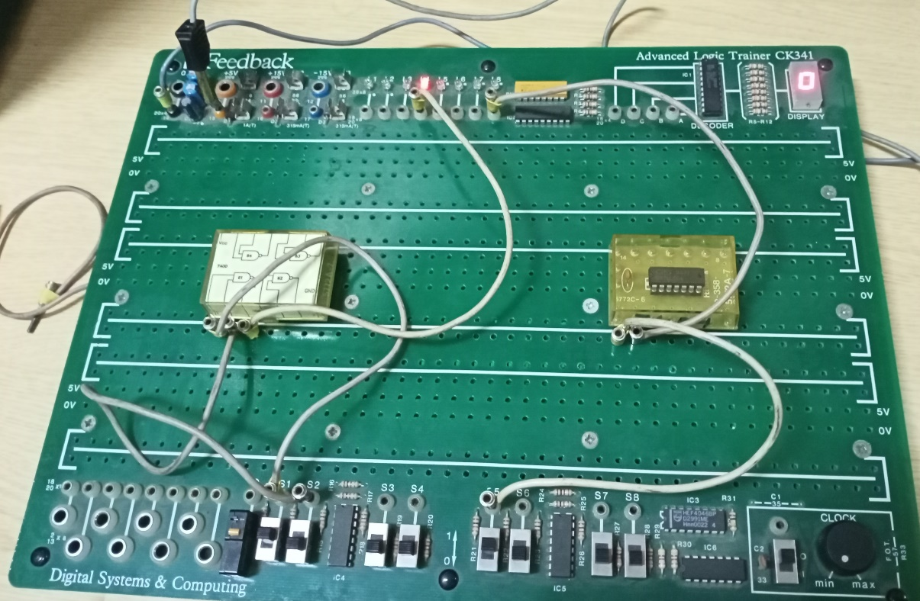

AND and NOT Gate Implemented Using 7400 and 7404 IC’s

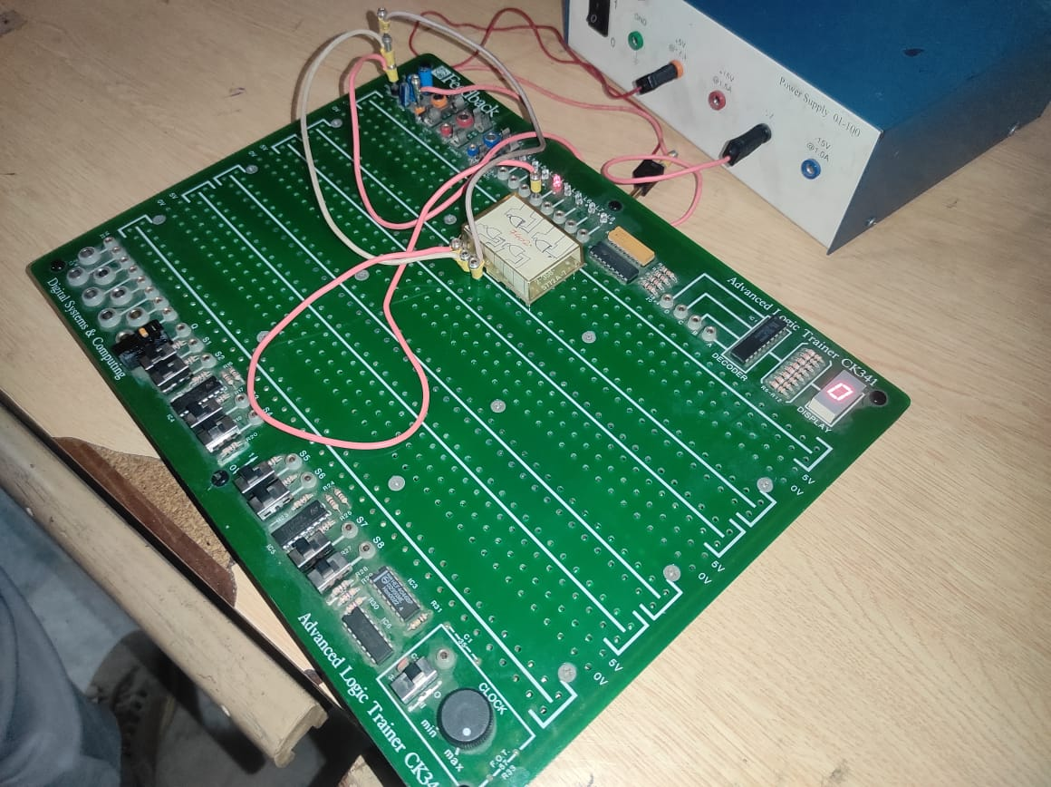

NOR Gate Implemented Using 7402 IC

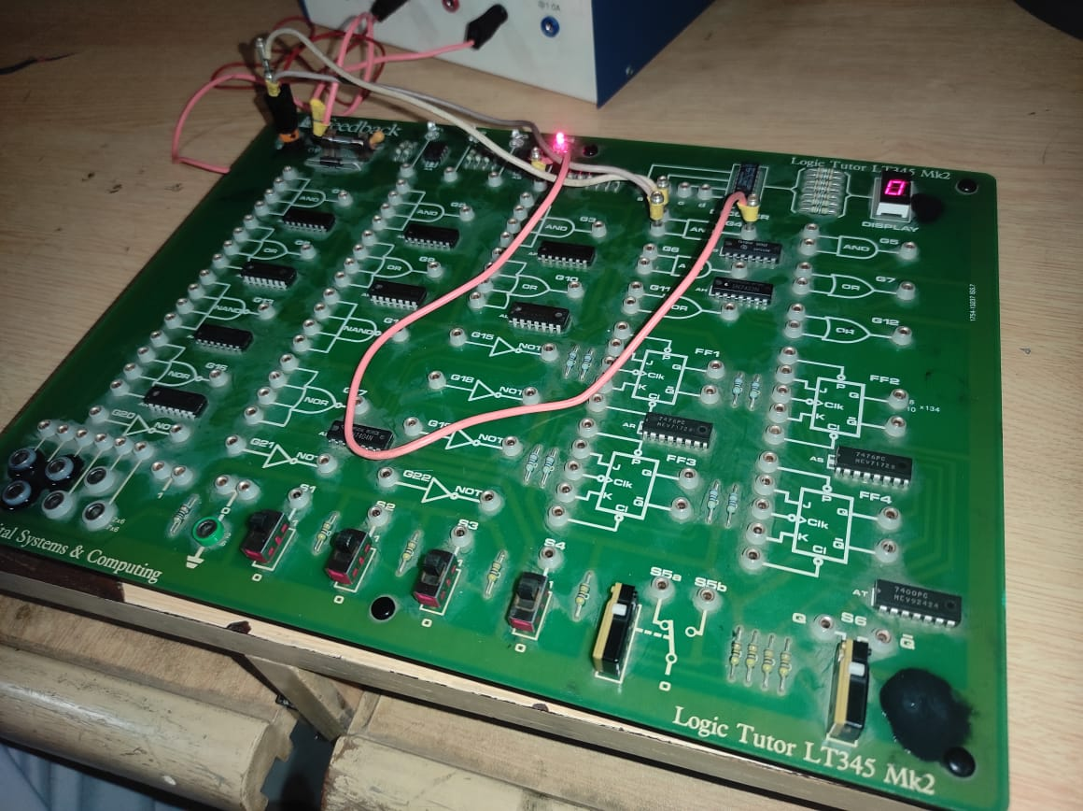

AND Gate Implemented Using 7408 IC

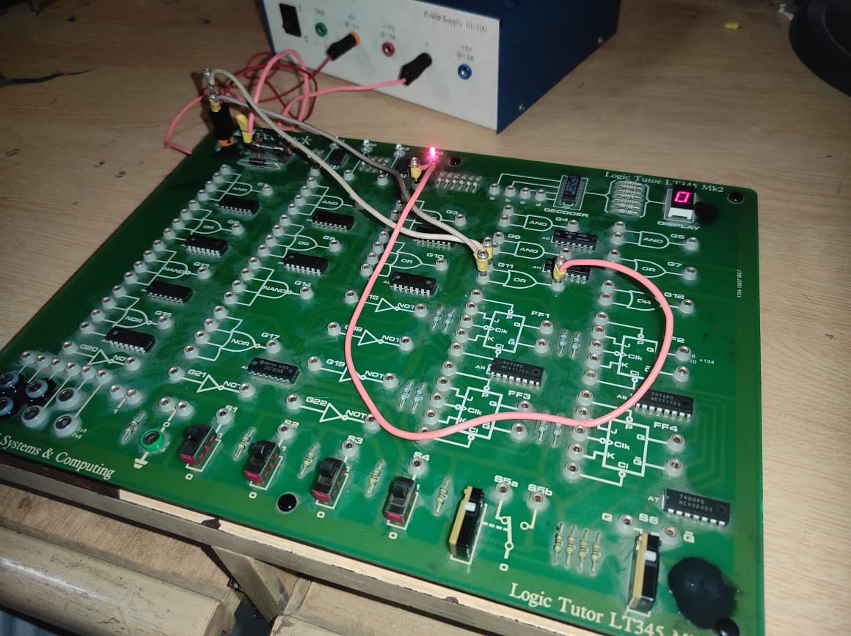

OR Gate Implemented Using 7432 IC

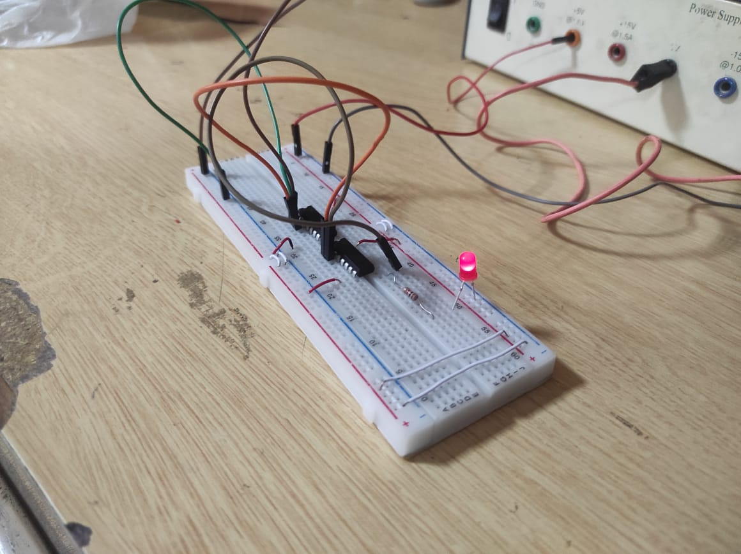

XOR and XNOR Gate Implemented Using 7404 and 7486 IC’s

LAB READINGS:

Table 1: Truth Table for Inverter (NOT Gate)

|  |  |  |
| --- | --- | --- |
| A (High/Low) | Y (Volts) | Y (High/Low) |
| Low | 4.00 V | High |
| High | 0.081 V | Low |

Table 2: Truth Table for AND & OR Gates

|  |  |  |  |  |  |
| --- | --- | --- | --- | --- | --- |
| A (H/L) | B (H/L) | AND2 (V) | AND2 (H/L) | OR2 (V) | OR2 (H/L) |
| L | L | 0.073 V | L | 0.044 V | L |
| L | H | 0.074 V | L | 3.91 V | H |
| H | L | 0.074 V | L | 3.91 V | H |
| H | H | 3.93 V | H | 3.91 V | H |

Table 3: Truth Table for NAND, NOR, & XOR Gates

|  |  |  |  |  |  |  |  |
| --- | --- | --- | --- | --- | --- | --- | --- |
| A (H/L) | B (H/L) | NAND2 (V) | NAND2 (H/L) | NOR2 (V) | NOR2 (H/L) | XOR2 (V) | XOR2 (H/L) |
| L | L | 3.37 V | H | 4.81 V | H | 0.007 V | L |
| L | H | 3.45 V | H | 0.081 V | L | 5 V | H |
| H | L | 3.40 V | H | 0.081 V | L | 5 V | H |
| H | H | 0.058 V | L | 0.081 V | L | 0.007 V | L |